______________________The Greater Augusta HBCU Alumni Alliance

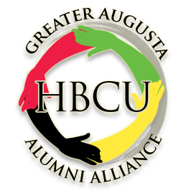

Dear Potential Alliance Member:

The Greater Augusta HBCU Alumni Alliance was organized in 2013 as a non-profit organization. Our mission
is to increase the visibility of Historically Black Colleges and Universities in the high schools and encourage students
to strongly consider HBCUs when deciding what college to attend.

We sponsor an HBCU college fair annually as well as participate in fairs sponsored be local schools and churches.
Scholarships are awarded each year to graduating seniors planning to attend an HBCU. Funds raised to support the scholarship are generated from proceeds of the Annual Augusta HBCU 5K Fun Run/Walk and Health Fair. We support the community by donating food baskets and school supplies to needy families.

It is our desire that all local HBCU chapters join the alliance. There is a one-time chapter joining fee of $250 that
is applied to operating funds. Checks are to be made payable to: Augusta HBCU Alumni Alliance. There are no dues.

The Augusta HBCU Alliance meets the 4th Saturday in the month at the Highland Avenue Fire Station #8 @ 9:00am.
Presently we are meeting via “Zoom” because of COVID concerns.

We are actively looking for new and creative ways to serve the community. Come join us, there is a lot of good
that can be accomplished when we work together.

Please complete the Information below and mail with check to: Rose Walker, Treasurer
2921 Nighthawk Drive
Augusta, GA 30906
Sincerely,

Raymond McCoy
Raymond McCoy, President (706) 799-2123
HBCU CHAPTER INFORMATION SHEET
HBCU Chapter __________________________________________________________________
Contact Person __________________________________________________________________
Address_________________________________________________________________________
City_________________________________State_______________Zip_____________________
Phone_______________________________ Email______________________________________
____ Yes, I want to become a member of the Greater Augusta HBCU Alumni Alliance.
Signature___________________________________________ Date__________________
Greater Augusta Historically Black Colleges and Universities Alumni Alliance
P. O. Box 5329 Augusta, GA 30916
www.augustahbcualumni.com

